Title I, Part A Schoolwide Plan Template
Purpose and Directions
Utah Title I Schoolwide Planning Template

Part A: General Information

School Name: West Jordan Elementary | LEA Name: Jordan District

Title I Schoolwide Planning Team | Name | Signature
Principal | Jennifer Ludlow
Title I facilitator or coordinator | Angela Hamilton
Faculty Member | Connor Sullivan
Faculty Member | Jamie Atkins
Classified Member | Nancy Gustaveson
Parent Representative | Marta Dalton
School Community Council Representative | Samantha Robinson

Schoolwide Title I plan must be developed with the meaningful involvement and input of parents, other members of the community to be served, and teachers and staff who will carry out the plan.

LEA Title I Director | Signature | Date
Principal: Jennifer Ludlow | Signature | Date

Updated 9-8-2017 by USBE Title I ADA Compliant: 06/06/2018

Title I, Part A Schoolwide Plan Template
Purpose and Directions

West Jordan Elementary has 491 students enrolled in the 2019-2020 school year. 228 students are female and 263 students are male. 29% of our student population are of ethnic minority. 11% of our students are English Language Learners. 48% of our students are economically disadvantaged. Lastly, 19% of our students are involved in special education.

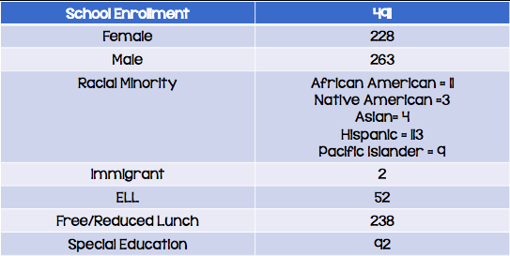

Teacher Qualifications:

At West Jordan Elementary, 13 classroom teachers and the school principal are ESL endorsed, while 2 classroom teachers are enrolled to begin their ESL endorsement program through the Jordan School District in January of 2020.

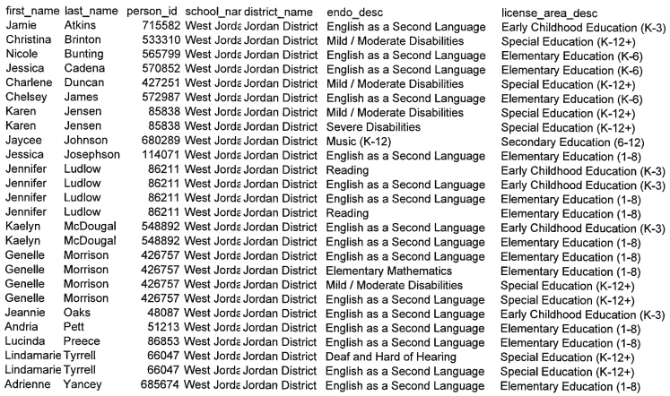
Comprehensive Needs Assessment
ESSA Sec. 1114(b)(6)
Schoolwide project schools must conduct a comprehensive needs assessment of the entire school, based on the information about the performance of students in relation to the State’s academic standards (Utah State Core Standards). Quality needs assessments include multiple sources of data. Some to consider are:

Student Achievement Data:

Rise Results Over Time

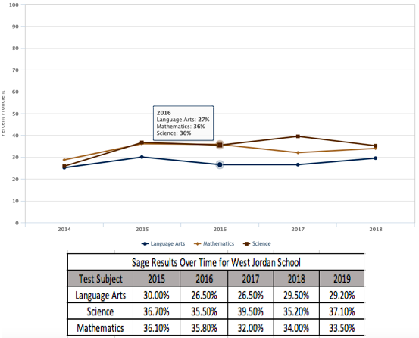

District Benchmarks:

ELA: From Pre to Post Test, our school went from an overall score of 10% proficient to 36% proficient in ELA with an overall growth score of 26%. 1st Grade showed the most growth starting the year at 8% and ending with a proficiency of 85%.

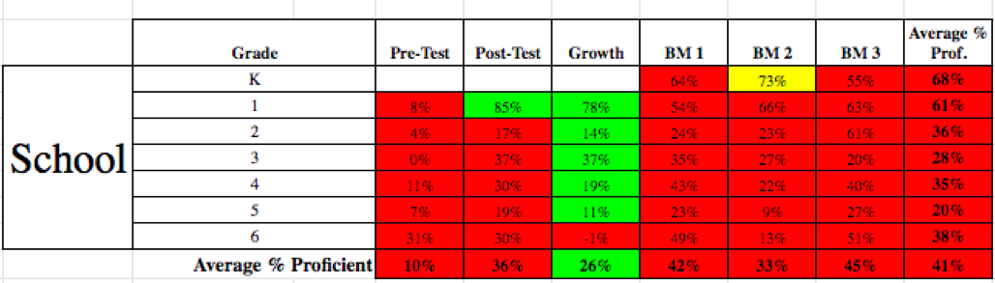

WRITING: From Pre to Post Test, our school went from an overall score of 4% proficient to 39% proficient in Writing with an overall growth score of 35%.

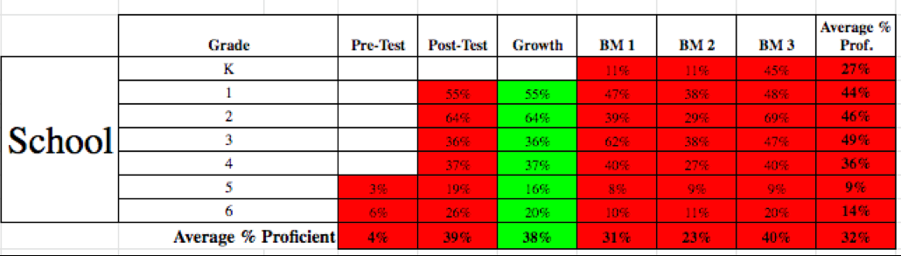

MATH: From Pre to Post Test, our school went from an overall score of 0% proficient to 38% proficient in Math with an overall growth score of 38%. 1st Grade showed the most growth starting the year at 0% and ending with a proficiency of 74%.

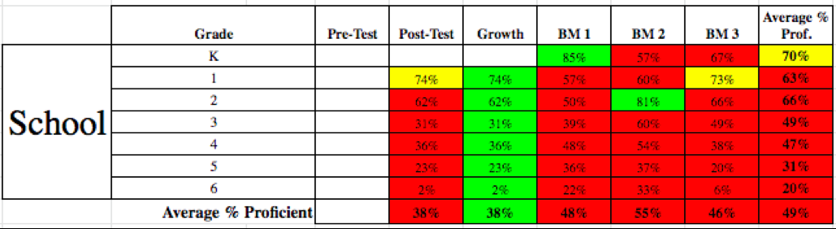

DIBELS: In the 2028-2019 school year, we had 39.4% of our kindergarten students make typical, above typical, or well above typical on their end of year Pathway of Progress as shown in their final DIBELS assessment. In 1st Grade, 43.4% of our students ended the year making typical, above typical, or well above typical progress according to their final DIBELS assessment. In 2nd Grade, we had the greatest amount of students show growth reaching 61.7% at typical, above typical, or well above typical by the end of year DIBELS assessment. Finally, in 3rd Grade, we 42.6% of our students meet the pathways of progress growth goal by the end of year assessment.

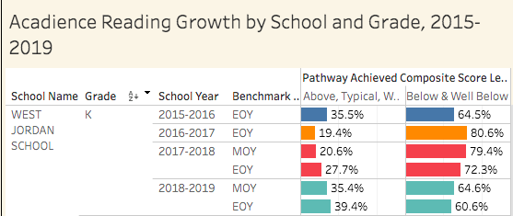
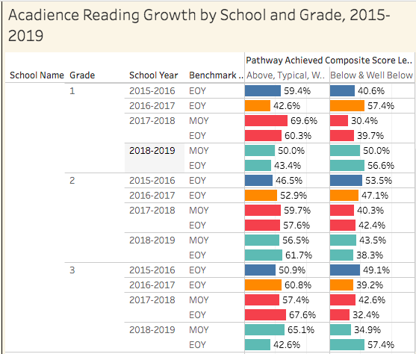

School Climate:

At the end of the 2018-2019 school year, teachers were asked to complete a survey regarding school climate. Overall, teachers are mostly satisfied with the climate of West Jordan Elementary. Teachers scored the “Resources” section of the survey the highest, with an overall average of 99.5%. Our lowest ranked area at 83% showed that teachers feel that expectations for academic achievement from parents could be improved.

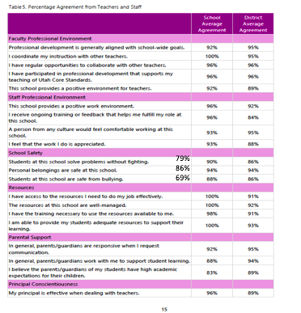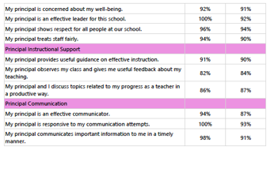

At the end of the 2018-2019 school year, parents were asked to complete a survey regarding school climate. Overall, parents are very satisfied with the climate of West Jordan Elementary. 99% of parents feel that the principal prioritizes the learning needs of each child, teachers are good role models, and that teacher communication methods are done well. The lowest rated area on our parent survey at 86% was the feeling that the school does a good job at keeping kids safe from bullying. This, however, is a 6% increase in the response from parents in the 2017-2018 survey results.

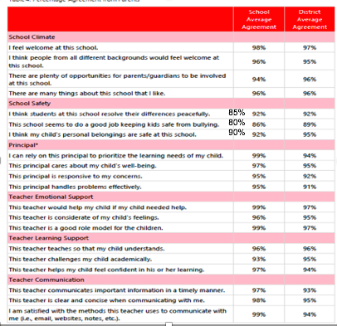

At the end of the 2018-2019 school year, students were asked to complete a survey regarding school climate. Overall, students are satisfied with the climate of West Jordan Elementary. The highest ranked area was “my principal looks out for all kids at our school” with an average of 97%. The lowest area was “Kids at my school solve problems without fighting.” ranking at 65%. This, however, is an increase of 3% from our 2017-2018 survey results from students.

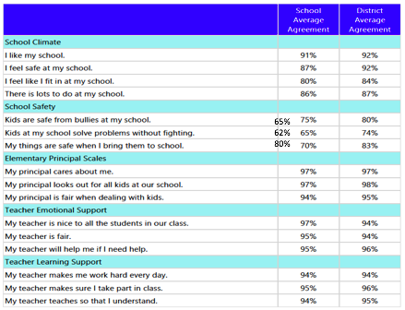

Instructional Practices:

- Cooperative Learning
- Setting Objectives - I Can Statements
- Providing Feedback
- School-Wide Graphic Organizers for Writing
- Explicit Instruction
- Technology in the Classroom (One-to-One)
- Differentiation

Title I, Part A Schoolwide Plan Template
Purpose and Directions

Schoolwide Reform Goals and Strategies Form

Complete one page for each goal.

SMART Goals should be directly related to the results of the comprehensive needs assessment and tied to the Utah State Standards

SMART Goal | Improve Math performance by 2% overall on RISE and have at least 90% of our teachers make the district growth goal on the Math SLO.
Strategies | I. Ensure quality of Tier 1 Instruction is provided in all classrooms, and offers to all students of varying needs and skills by:  A. Creating lessons and common assessments through PLC and common planning time during PE, computers, music, and art. Time will be spent reviewing data individually, and also spent during collaborative time in grade level PLCs.  B. Providing students with an environment where they can develop, explain, and show their mathematical comprehension and ability.  C. Full-time, experienced teachers/teacher specialists will be hired to assist in the areas of literacy, math, and school culture. In addition, these coaches will train and work with assistants at each grade level. They will be on extended contracts. Teacher specialists and aides will be hired to teach PE, music, computers and art so that teachers have additional time for collaboration and planning.  D. Grade level teams will follow math curriculum maps to guide instruction and create a focus on delivering core instruction.  E. Teachers will identify essential standards that will be given priority in instruction, assessment and intervention.  F. Provide All Day kindergarten to lower the Achievement Gap for at- risk and ELL students.  G. Fund ESL endorsements for all licensed teachers to meet the  needs of all ELL students.  H. Purchase necessary technology to be used in the classroom to  provide additional learning resources for all students.  I. Hire highly qualified classroom assistants, when needed, to provide  additional support for teachers and students in the classroom. The test is funded for those who pass.  II. Facilitate Tier II and Tier III instruction for students in need based on assessments.  A. Provide students with different settings conducive to skill levels through whole group, small group, and individual work to ensure opportunity for discussion and high engagement.  B. Instructional aides will be hired to assist classroom teachers during the RTI blocks in math and language arts. In math, they will be used to enrich students who have mastered the grade level content for the week.  C. Identify individual student needs based on RISE assessments for grades 3-6, and unit assessments for all grades.  D. Group students according to targeted needs based on common assessment data. Instruction, remediation, and enrichment activities to be performed by regular education teachers with assistance from Instructional aides. Teachers will meet in PLCs to create and analyze CFAs to identify students levels of proficiency and identify needs for intervention and enrichment.  E. Curriculum planning days are provided three times a year for teachers to plan and align curriculum with the standards.  III. Implement PLC’s to facilitate collaboration among staff and increase levels of learning for all students.  - Purchase materials, such as textbooks, that are critical for PLC training and collaboration.  B. Teams will have regularly scheduled times to collaborate weekly.  C. Teams will have time to create assessments and analyze the results of the data.  D. During PLCs, create remediation for students who did not meet proficiency, and enrichment for kids who achieved proficiency.  E. Hire aides and teacher specialists to support student learning in extracurricular areas while teachers are in PLCs.  lV. Increase parental involvement to improve math skills.  - Provide a Mommy and Me preschool to involve and educate families, and improve math instruction in the home.  - Hold an annual Family Math Night in which parents and students engage in literacy activities that will improve math at school and in the home.
Evidence-Based Research Support | - Houghton Mifflin Harcourt (2010). Math Expressions. Orlando, FL: Houghton Mifflin Harcourt.  - Ainsworth, L., & Viegut, D. (2006). Common formative assessments: How to connect standards-based instruction and assessment. Thousand Oaks, CA: Corwin Press.  DuFour, R. (2010). Learning by doing: A handbook for professional learning communities at work (2nd ed.). Bloomington, IN: Solution Tree Press.  Hattie, J. (2012). Visible learning for teachers: Maximizing impact on learning. London: Routledge.  - Santoyo, P. (2010). Driven by data: A practical guide to improve instruction. San Francisco, CA: Jossey -Bass.  - Santoyo, P., & Peiser, B. (2012). Leverage leadership: A practical guide to building exceptional schools. San Francisco: Jossey-Bass.  - Wiggins, G., & McTighe, J. (2005). Understanding by design (Expanded 2nd ed.). Alexandria, VA: Association for Supervision and Curriculum Development.
Expected Impact in Core Academic Areas  (How will success be measured on an annual basis?) | RISE Growth of at least 2% is the expected impact of high level math instruction. It is also expected that at least 90% of our teachers make the district growth goal on the Math SLO. We will compare last year’s results against this year’s results.
Professional Development to Support Strategies | - Each grade will receive 200 minutes of planning and collaboration time each week to work with their grade level team. Some of this time will be spent reviewing data individually. Time will also be spent in the collaborative work of PLCs. School leadership team members will regularly visit these daily meetings to provide necessary guidance as grade level teams continue developing into effective professional learning communities.  - Coaches will attend networking opportunities to collaborate with other schools.  - Support teachers as they work to obtain an ESL endorsement.  - Regular, differentiated professional development opportunities will be made available to teachers based on need.  - Monthly new teacher meetings will be held to support provisional teachers, but all staff are welcome to attend.
Timeline | Beginning of year and on-going throughout the year, or as needed.
Responsible Parties | Administration  - Classroom Teachers  - Teacher Specialists  - Certified Interventionists  - District Specialists
Evaluation Process  (How will the school monitor the implementation of the strategies and action steps associated with this goal?) | - As a part of each team’s daily collaborative PLC time, grade level teams will schedule data meetings to discuss Common Formative Assessment data. School leadership team members will attend these meetings.  - Our school leadership team will conduct weekly observations to  collect coaching data as they work with individual teachers.  This data will be shared within three days to provide timely and  effective feedback.

Title I, Part A Schoolwide Plan Template
Purpose and Directions

Schoolwide Reform Goals and Strategies Form

Complete one page for each goal.

SMART Goals should be directly related to the results of the comprehensive needs assessment and tied to the Utah State Standards

SMART Goal | Achieve at least 60% of students meeting typical or better progress on Acadience (DIBELS)
Strategies | I. Ensure quality of Tier 1 Instruction is provided in all classrooms, and offers to all students of varying needs and skills by:  A. Creating lessons and common assessments through PLC and common planning time during PE, computers, music, and art. Time will be spent reviewing data individually, and during collaborative time in grade level PLCs.  B. Provide ongoing Professional Development on Lexia and Acadience strategies that can be implemented in the classroom.  C. Full-time, experienced teachers/teacher specialists will be hired to assist in the areas of literacy, math, and school culture. In addition, these coaches will train and work with assistants at each grade level.. Teacher specialists and assistants will be hired to teach PE, Music, computers and art so that teachers have additional time for collaboration and planning.  D. Grade level teams will use language arts curriculum maps to guide instruction and create a focus on delivering core instruction.  E. Teachers will identify essential standards that will be given priority in instruction, assessment and intervention.  F. Implement Heggerty in K-2 and utilize the Fidelity Checklist.  G. Implement 95% Group in K-1 and utilize PLC time to identify students needing Tier 2 instruction using the 95% Group program.  H. Teachers and assistants progress monitor for Acadience Reading.  I. A universal screener will be administered to all students K-6 identified as  level.(K-3 reds, yellows, low-greens, 4-6 students below level on beginning of year F&P assessment)  J. Provide All Day kindergarten to lower the Achievement Gap for at- risk and ELL students.  K. Fund ESL endorsements for all licensed teachers to meet the  needs of all ELL students.  L. Purchase necessary technology to be used in the classroom to provide additional learning resources for all students.  M. Hire classroom assistants to provide additional support for teachers and students in all classrooms during RTI blocks of instruction, and in grades K-2.  N. Curriculum planning days are provided three times a year for teachers to plan and align curriculum with the standards.  II. Facilitate Tier II and Tier III instruction for students in need based on assessments.  A. Provide students with different settings conducive to skill levels in whole groups, small groups, and individually to ensure opportunity for discussion and high engagement.  B. Assistants will be hired to enrich and reteach in math and language arts.  C. Identify individual student needs based on RISE assessments for grades  3-6, Acadience assessments for grades K-3, and benchmarks and unit tests in all grades.  D. Group students according to targeted needs based on common assessment data. Teachers will meet in PLCs to create and analyze CFAs to identify students levels of proficiency and determine needs for intervention and enrichment.  III. Implement PLC’s to facilitate collaboration among staff and increase levels of  learning for all students.  A. Purchase materials, such as textbooks, that are critical for PLC  training and collaboration.  B. Teams will have regularly scheduled times to collaborate  weekly.  C. Teams will have time to create assessments and analyze the  results of the data.  D. During PLCs, create remediation for students who did not meet  proficiency, and enrichment for kids who achieved proficiency.  E. Hire aides to support student learning in extracurricular areas  while teachers are in PLCs.  lV. Increase parental involvement to improve literacy.  - Provide a Mommy and Me preschool to involve and educate families, and improve literacy instruction in the home.  - Hold an annual Family Literacy Night in which parents and students engage in literacy activities that will improve literacy at school and in the home.  - Hold Parents and Pastries events that will engage parents and students in reading books together to encourage literacy at school and at home.
Evidence-Based Research Support | Houghton Mifflin Harcourt (2018). Journeys. Orlando, Florida:Houghton Mifflin Harcourt  - Auman, Maureen (2016). Step Up to Writing. Dallas, TX: Voyager Sopris Learning, Inc.  Ainsworth, L., & Viegut, D. (2006). Common formative assessments: How to connect standards-based instruction and assessment. Thousand Oaks, CA: Corwin Press.  DuFour, R. (2010). Learning by doing: A handbook for professional learning communities at work (2nd ed.). Bloomington, IN: Solution Tree Press.  - Platt, A. (2000). The skillful leader: Confronting mediocre teaching. Acton, Mass.: Ready About Press  - Santoyo, P. (2010). Driven by data: A practical guide to improve instruction. San Francisco, CA: Jossey Bass.  - Santoyo, P., & Peiser, B. (2012). Leverage leadership: A practical guide to building exceptional schools. San Francisco: Jossey-Bass.  - Wiggins, G., & McTighe, J. (2005). Understanding by design (Expanded 2nd ed.). Alexandria, VA: Association for Supervision and Curriculum Development.
Expected Impact in Core Academic Areas  (How will success be measured on an annual basis?) | Improvement in RISE, Acadience, Running Records, Fountas & Pinnell, Common Formative Assessments, and District Benchmark Assessment data due to an improvement in Tier I instruction, targeted intervention instruction at Tiers II and III, improvement in the collaborative practices of grade level professional learning communities. We also anticipate higher involvement of parents, patrons, and the community in instructional opportunities. Teachers will also use district writing rubrics or Utah Compose to grade student writing pieces. We expect this monitored practice to improve RISE Assessment data.
Professional Development to Support Strategies | - Each grade will receive 200 minutes of planning and collaboration time each week to work with their grade level team. Some of this time will be spent reviewing data individually, and time will also be spent in the collaborative work of PLCs. School leadership team members will regularly visit these daily meetings to provide necessary guidance as grade level teams continue developing into effective professional learning communities.  - Coaches will attend networking opportunities to collaborate with other schools.  - Support teachers as they work to obtain an ESL endorsement.  - Regular, differentiated professional development opportunities will be made available to teachers based on need  - Monthly new teacher meetings will be held to support provisional teachers, but all staff are welcome to attend.
Timeline | 1. Start implementing Heggerty Day 1.  2. Implement 95% Group progress monitoring by October 1  3 .Progress monitor training for aides and teachers using Acadience by the end of September.  4. Progress monitor reds and yellows once a week, greens and  blues twice a month by focusing on one skill at a time.  5. Universal screener will be administered by September 30
Responsible Parties | Administration  - Classroom Teachers  - Teacher Specialists  - Certified Interventionists  - District Specialists  - JELL Team
Evaluation Process  (How will the school monitor the implementation of the strategies and action steps associated with this goal?) | - Teachers will gather informal observations using progress monitoring and checklists.  - Coaches and Jen will see teachers using Heggerty in lessons.  - Teachers will discuss these informal observations in PLCs.  - JELL team will gather Acadience progress monitoring data.  - As a part of each team’s daily collaborative PLC time, grade level teams will schedule data meetings to discuss Common Formative Assessment data. School leadership team members will attend these meetings.  - Our school leadership team will conduct observations to ensure teachers are implementing and following the curriculum map created as a grade level.  - Our school leadership team will collect coaching data as they coach individual teachers. This data will be shared within three days to provide timely and effective feedback.

Title I, Part A Schoolwide Plan Template
Purpose and Directions

Schoolwide Reform Goals and Strategies Form

Complete one page for each goal.

SMART Goals should be directly related to the results of the comprehensive needs assessment and tied to the Utah State Standards

SMART Goal | Improve our school culture with a 3% growth in the targeted area of School Safety student responses, specifically as it relates to bullying, and solving problems without fighting, as identified from our 2018-19 school survey and re-evaluated in our 2019-20 school survey.
Strategies | - Teachers will be trained on the school-wide behavior plan. Any questions or inconsistencies can be resolved at that time.  - School wide expectations will be posted throughout the school and students will be taught what expectations look like and sound like throughout the building during a Culture Week the first week of school. Teachers will model poor examples and students will model good examples. A schedule will be created for these rotations.  - Morning meetings will be held each day to help establish a positive sense of community in each classroom. Teachers will be trained on the morning meeting format during opening days and support and coaching will be offered as needed.  - Teachers will implement a system of their choice for positives in their classrooms to supplement the school wide behavior plan.  - Teachers will post classroom rules, voice levels, and hierarchies of consequences in their classrooms and follow the established procedures.  - Teachers will start each day greeting students at the door, and will have a self starter immediately accessible to kids so that they can start the day busy and engaged in learning activities.  - Teachers will be taught the difference between an office referral and what should be handled within the classroom and will be held accountable for what falls within their stewardship.  - Structured Recess will be offered for students who continue to struggle both in and out of the classroom and need a tier 2 level of support. Students can be placed on an Empower Play recess contract that includes check in and check out time with an identified adult.  - A social skills/anti-bullying program called Second Step will be utilized in morning meetings to teach positive social behaviors, conflict resolution skills, and anti-bullying strategies through age-appropriate curriculum. We will incorporate a kindness theme and encourage acts of kindness around the school.
Evidence-Based Research Support | DuFour, R. (2010). Learning by doing: A handbook for professional learning communities at work (2nd ed.). Bloomington, IN: Solution Tree Press.  Epstein, J. (2011). School, family, and community partnerships preparing educators and improving schools (2nd ed.). Boulder, CO: Westview Press.  - Gruenert, S. (2015) School Culture Rewired: How to Define, Assess, and Transform It. Alexandria, VA: ASCD  - Henderson, A. (2007) Beyond the Bake Sale: The Essential Guide to Family-School Partnerships. New York, NY: The New York Press  Hutchins, D. (2012) Multicultural Partnerships: Involve All Families. Larchmont, NY: Eye on Education.  - Thomas, B. (2012) Promising Partnership Practices. Baltimore, MD: National Network of Partnership Schools
Expected Impact in Core Academic Areas  (How will success be measured on an annual basis?) | Improvement in identified areas from our school survey including school safety, and school climate from the students as a result of ongoing training and feedback to teachers, and the Second Step lessons, along with Empower play to improve student relationships at recess. The results of the 2019-20 survey will be measured against the results of the 2018-19 survey with an anticipated 3 % growth in percentile.
Professional Development to Support Strategies | During our summer professional development days, our school leadership team provided professional development about the school-wide management system, morning meetings, and culture week.
Timeline | Beginning of year and on-going throughout the year.
Responsible Parties | Administration  - Classroom Teachers  - Instructional Coaches  - Structured Recess Aide  - Students  - Parents
Evaluation Process  (How will the school monitor the implementation of the strategies and action steps associated with this goal?) | Last year, only 75% of our students reported that they felt safe at school. We plan to survey students mid-year and end-of-year to get feedback about students’ opinions about whether or not school safety has improved. We anticipate a growth of 3% in school safety.

Funds to Support Our Schoolwide Program

Program | Amount Available | How the Intents are Purposes of the Program will be Met
PLC | $14,023 | Paying for art specialist during PLC times.
En Lieu | $24,824.42 | PD, quarterly planning days, assistants, math textbooks, misc expenses
Landtrust | $44,232 ($47,412.46) | RTI aides for math and reading, 25 hr Kindergarten Assistant
Supply | $22,904.88 | Misc school supplies, team budgets, paper, toner, etc.
Textbook | $5,684.61 | Math Textbooks (new adoption)
Technology | $28,534 | Computer lab assistant, programs, etc
Equipment | $8,161 | Moving to supply budget to cover the cost of school supplies
Title 1 Funds | $243,113.73 | Instructional Coaches, Music Specialist (60%), ESL endorsements, assistants, PD and stipends
Parent Involvement | $5,563 | Money will be spent for community events to encourage parents to be involved in our school.
McKinney Vento Assistant | $9,000 | Assistant hired to help with the needs of homeless students and families in need
Family Learning Center | $500 for supplies + $8,00 for an aide. | To increase parent involvement through Mommy and Me preschool.
TSSA | $69, 557 | To increase teacher capacity through coaching, and implementation of early literacy programs.

